UNIT 3. A WALK THOUGH THE NATURE

LIVING THINGS:  ARE BORN:  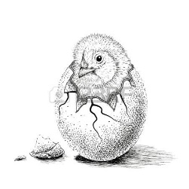  EAT:  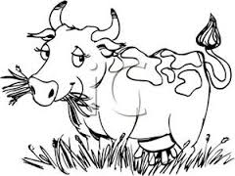  BREATHE:  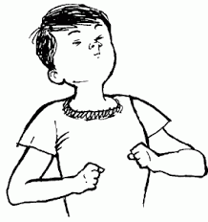  GROW:  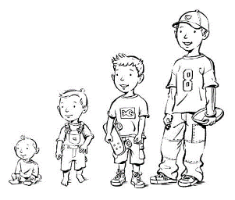  REPRODUCE:  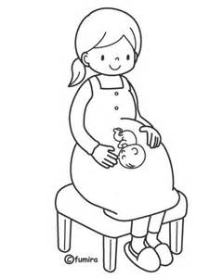  DIE:  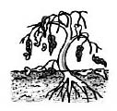 | NON-LIVING THINGS:  - ARE NOT BORN  - DON’T EAT  - DON’T BREATHE  - DON’T GROW  - DON’T REPRODUCE  - DON’T DIE  