UNIT 7: Sports and hobbies
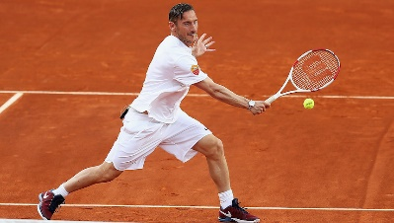 | 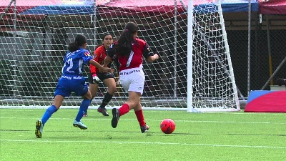
play tennis | play football | ride a bike
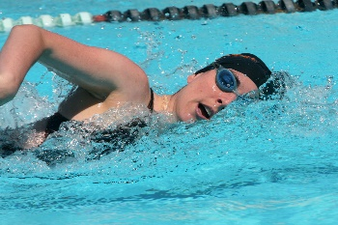 | 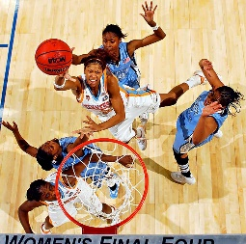 | 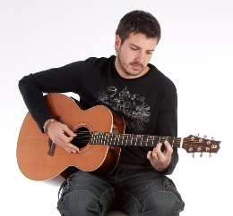
swim | play basketball | play the guitar
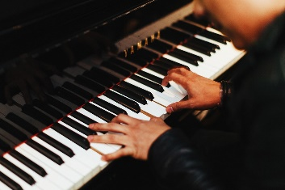 | 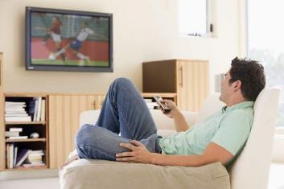 | 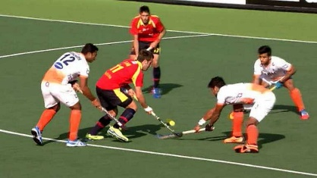
play the piano | watch television | hockey
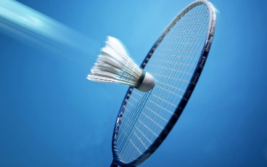 | 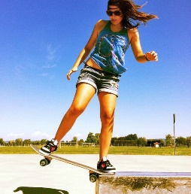
badminton | ride a skateboard

UNIT 7: Sports verbs
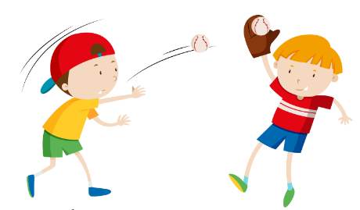
throw | catch | run
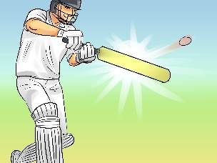 | 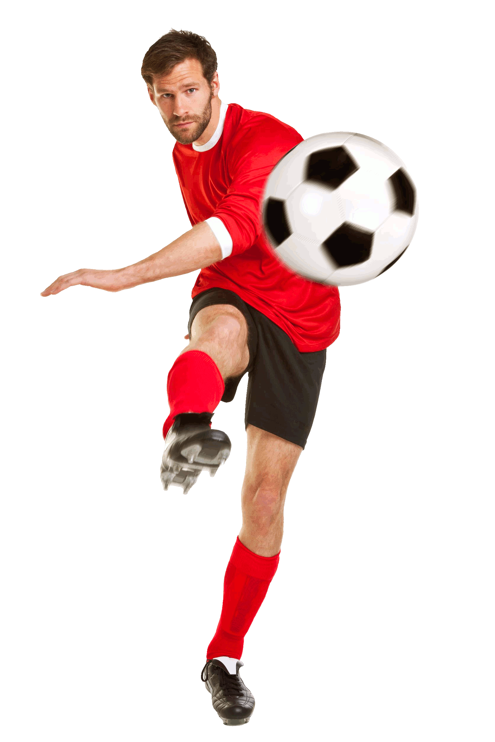
hit | kick

UNIT 7: Structures
What are you doing? | I’m riding a horse.
What’s she doing? | She’s swimming.
Are they cleaning the car? | Yes, they are. / No, they aren’t.

Can we play tennis? | Yes, you can, but you can’t play here.

