UNIT 8: Rooms and objects in the house
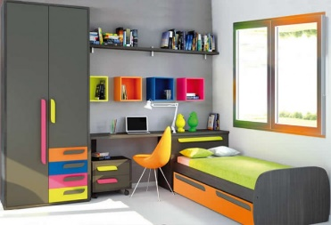 | 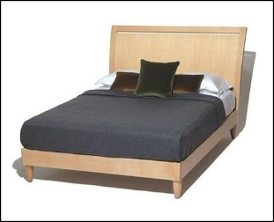 | 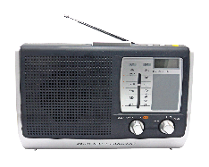
bedroom | bed | radio
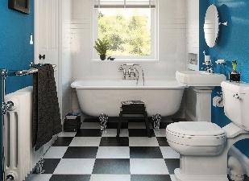 | 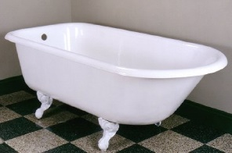 | 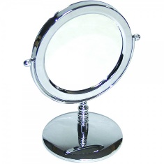
bathroom | bath | mirror
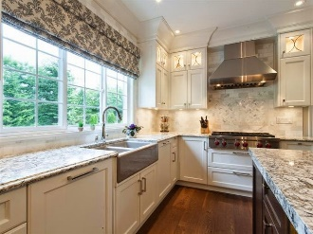 | 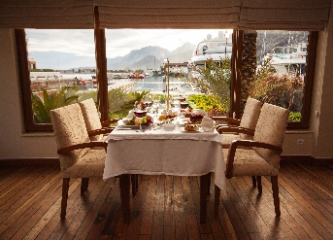 | 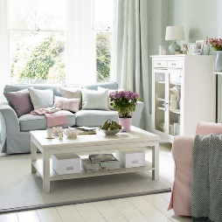
kitchen | dining room | living room
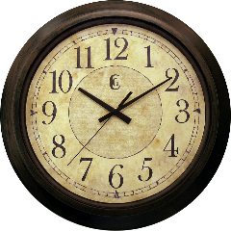 | 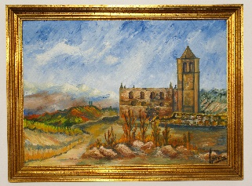 | 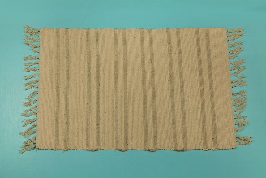
clock | painting | rug

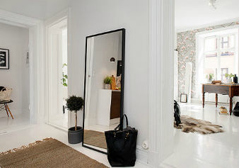 | 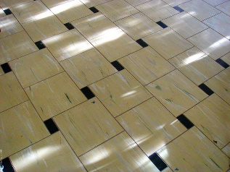 | 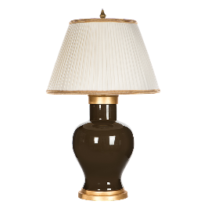
hall | floor | lamp
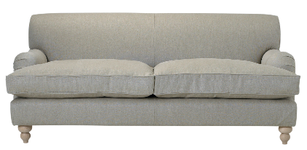 | 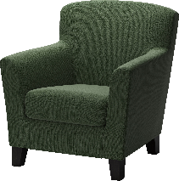 | 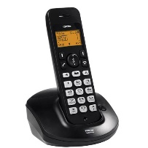
sofa | armchair | phone

UNIT 8: Structures
I can swim. |  | I can’t play the guitar.
She can play the piano. |  | He can’t sing.
Can you ride a horse? |  | Yes, I can. / No, I can’t.
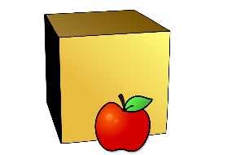 | 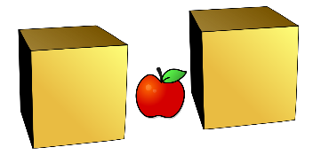 |  | 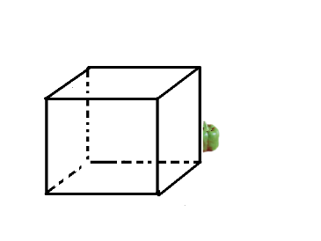
in front of | between |  | behind

There’s a small rug in front of the armchair.

There’s a lamp between the armchair and the sofa.

There’s a clock on the wall behind the sofa.

